

Programme Name: ________**BCS HONS**_______________________________________

Course Code: __**CSC 2330** _______

Course Name: ___**Software Project Management**_____ ______________________________

**Assignment** / Lab Sheet/ Project / Case Study No. _**1**___

Date of Submission: ______**/2020**_____________

**Submitted By: Submitted To:**

Student Name**: Dipesh Tha Shrestha** Faculty Name**:** **Satyam Paudel**

IUKL ID: **041902900028** Department**: LMS**

Semester**: Third Semester**

Intake**: September 2019**

**Website Development Project**

**Date:**12/12/2020

**Project Plan**: Prabhu Store

**Presented to**: Prabhu Bank limted

**Presented by:** Dipesh Tha Shrestha

**Project Description:** In this project, we are going to create an website for online store or online shopping page of parbhu which will be named as prabhu store. It is sponsor by Prahhu bank.

**Final Delivery Date**: may 23th 2021

**Introduction of the organization:**

Prabhu Bank Limited is a commercial bank in Nepal. The bank is an ‘A’ class commercial bank licensed by Nepal Rastra Bank and has branches all across the nation with its head office in Kathmandu which provides entire commercial banking services.

The bank's shares are publicly traded as an 'A' category company in the Nepal Stock Exchange. It is one of the highest-earning banks in Nepal and is one of the banks having the highest number of shareholders.

The bank has been maintaining harmonious correspondent relationships with various international banks from various countries to facilitate trade, remittance, and other cross border services. Through these correspondents, the bank is able to provide services in any major currencies in the world.

Prabhu store will an online marketplace and logistics company which operates in markets of Nepal. This website will compete with website like daraz and sastodeal. Prabhu store is sponsor by prabhu bank.

**Introduction:** Thepurpose of this project is to create a website for a Prahu Store. The name of project is Prabhu store website. Prabhu Bank is one of the most popular bank in Nepal. So, Prahu bank is trying to make their own ecommerce website. They named their website Prabu Store.

**Site Goals:**

* Selling a service or product.
* Providing product support or customer service.
* Providing corporate information.
* Establishing brand awareness and corporate identity.
* **create a differentiated customer experience to capture market share**.
* **reach new customers**,

**Site Objectives**

* Providing a unique customer experience
* Increasing the number of loyal customers
* Boosting the efficiency of services
* Developing relevant target
* Making responsive ecommerce website
* Increasing sales

**Project Charter and Scope statement**

|  |  |
| --- | --- |
| **Project Title** | Prabhu Store Website |
| **Project Manager** | Dipesh Tha Shrestha  Email: dipeshthashrestha@gmail.com |
| **Date of Authentication** | January 1st 2021 |
| **Project start Date** | January 1st 2021 |
| **Project Deadline** | May 1st 2021 |
| **Goals** | is to save time, save money. Through Prabhu store one can save his valuable time. One can watch and select things he wants to buy. Through **Prabhu store** one can save our money because prices are less than market prices and we receive our bought things at our home. |
| **Scope** | * No need to go to shop to buy good for customer which waste time. |
| **Objective** | * is to make it easy to do business anywhere * Improve online shopping system * Establish online based system * Decrease wait time of customer to |
| **Constraints** | Customer attitudes towards the new website.  Time is limited so the quality of website might not be good enough. |
| **Success Criteria** | * Quick Load Time. * Mobile Responsive. * Easy Check-out. * Clear calls-to-action. * Secure Shopping. * Social Sharing. * Product Reviews. * High Visibility Contact Info. |

**Roles and responsibilities**

|  |  |  |
| --- | --- | --- |
| **Name** | **Role** | **Position** |
| Prabhu Bank Limited | Sponsor | Sponsor |
| Dipesh Tha Shrestha | Team Member | Project manager |
| Kp oli | Team Member | Designer |
| Subash nepal | Team Member | Frontend Programmer |
| Prabhu shrestha | Team Member | Backend Programmer |
| Laxmi thapa | Team Member | Tester |

**Site advantage:**

* Save Time
* Save Fuel
* Save Energy
* Comparison of Prices
* 24/7 Availability
* Hate Waiting in Lines
* Too Ashamed to Buy
* Easy to Search Merchandise You Want to Buy

Site Assessment: (Specific description of the methods that will be used to evaluate the site’s effectiveness in meeting the stated objectives. The methods should describe activities in which measurable and/or observable behaviors or responses of the site’s users are recorded, analyzed and evaluated.)

**Site Uses:**

People uses this site or website for

* Faster buying process.
* Store and product listing creation.
* Cost reduction.
* Affordable advertising and marketing.
* Flexibility for customers.
* No reach limitations.
* Product and price comparison.
* Faster response to buyer/market demands.

**Site features:**

* Long scrolling webpages
* Video content will overtake written content
* Design with data
* Local search will get more local
* Focus on responsive
* Search engine optimisation

**Work breakdown structure.**

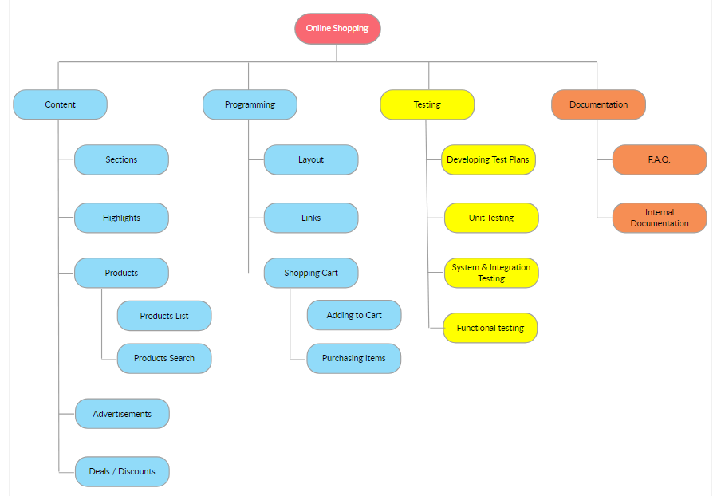

**Gantt Chart for Prabhhu Store Website**

**Network Diagram**

|  |  |  |
| --- | --- | --- |
| **Activities** | **Procedure** | **Duration** |
| Requirement gathering(A) | - | 14 |
| Planning(B) | - | 7 |
| Frontend designing(C) | A, B | 10 |
| Implementing Frontend design(D) | C | 18 |
| Backend of website(E) | D | 22 |
| testing website(F) | E | 8 |
| upload website in web(G) | F | 5 |
| gather feedback from client(H) | G | 14 |
| Handover the website(I) | H | 1 |

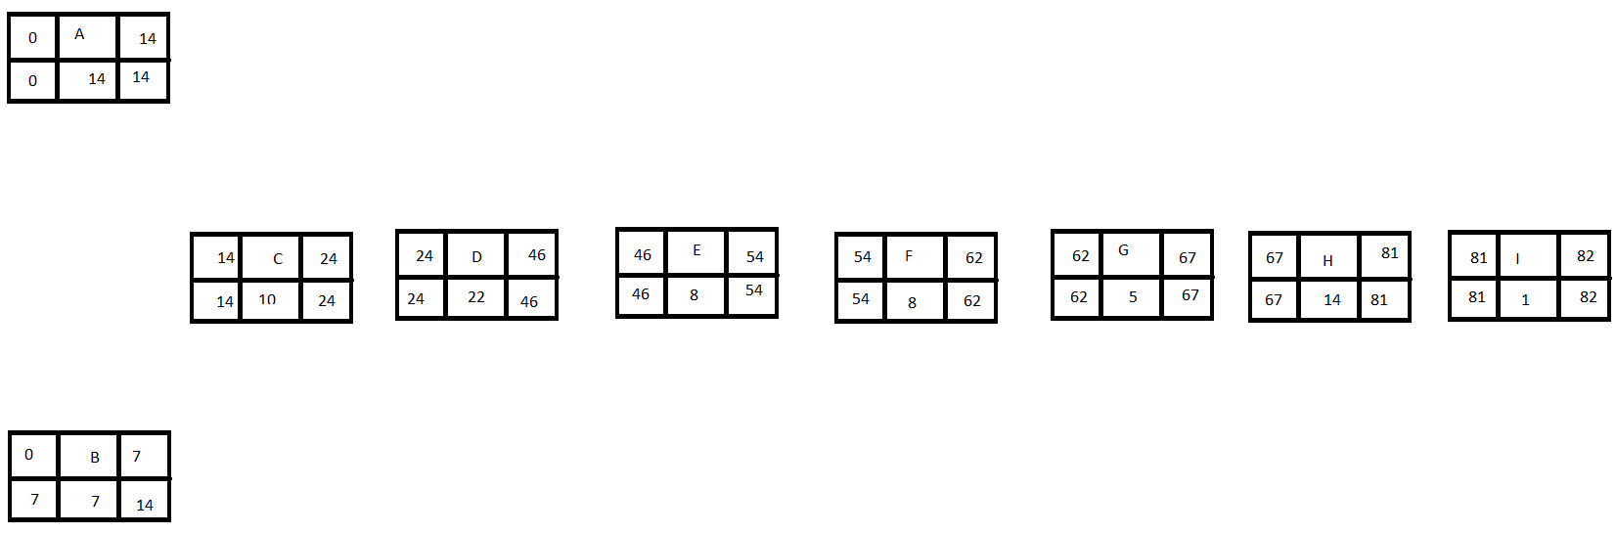

**Budget report**

The project is estimated to cost about $13,488. Only one person is involved in one task. Salary is paid on hourly based. Working days is number of days required to finish the project not the entire 4 months period of time. Like Saturday and the days between two tasks.

Audience Profile: (Identify the primary, secondary and subsidiary audiences. Include information about audience demographics, needs, attitudes, mind set, etc. Briefly describe how the site will meet their needs.)

Audience Technical Requirements: (Describe the minimum requirements regarding connectivity, computer platforms, web browsers, video monitors on which the web pages should render and function satisfactorily.)

Competitive Analysis: (Identify several existing web sites with similar target audiences, and goals. Describe the content, format, and features of these web sites that should and should not be incorporated into the design of this project site.)

Project Timeline (expressed in hours, weeks, months -- or name specific dates by which task sets will be completed):

• Technology Development (see document below)

• Content development

• Review processes (internal, external, OERI)

• Edit, revisions

• Review of final product

• Marketing strategies

• Final delivery Resource Planning:

• Tech development (including testing and analyses)

• Content development

• Editing

• Review processes

• Marketing Agreement of Stakeholders: Sign-off of key technology and program staff, advisory committees, etc. Project Plan Overview Submitted by:___________________________________________ Date:___________ Project Plan Approved by:____________________________

_______________ Date:___________